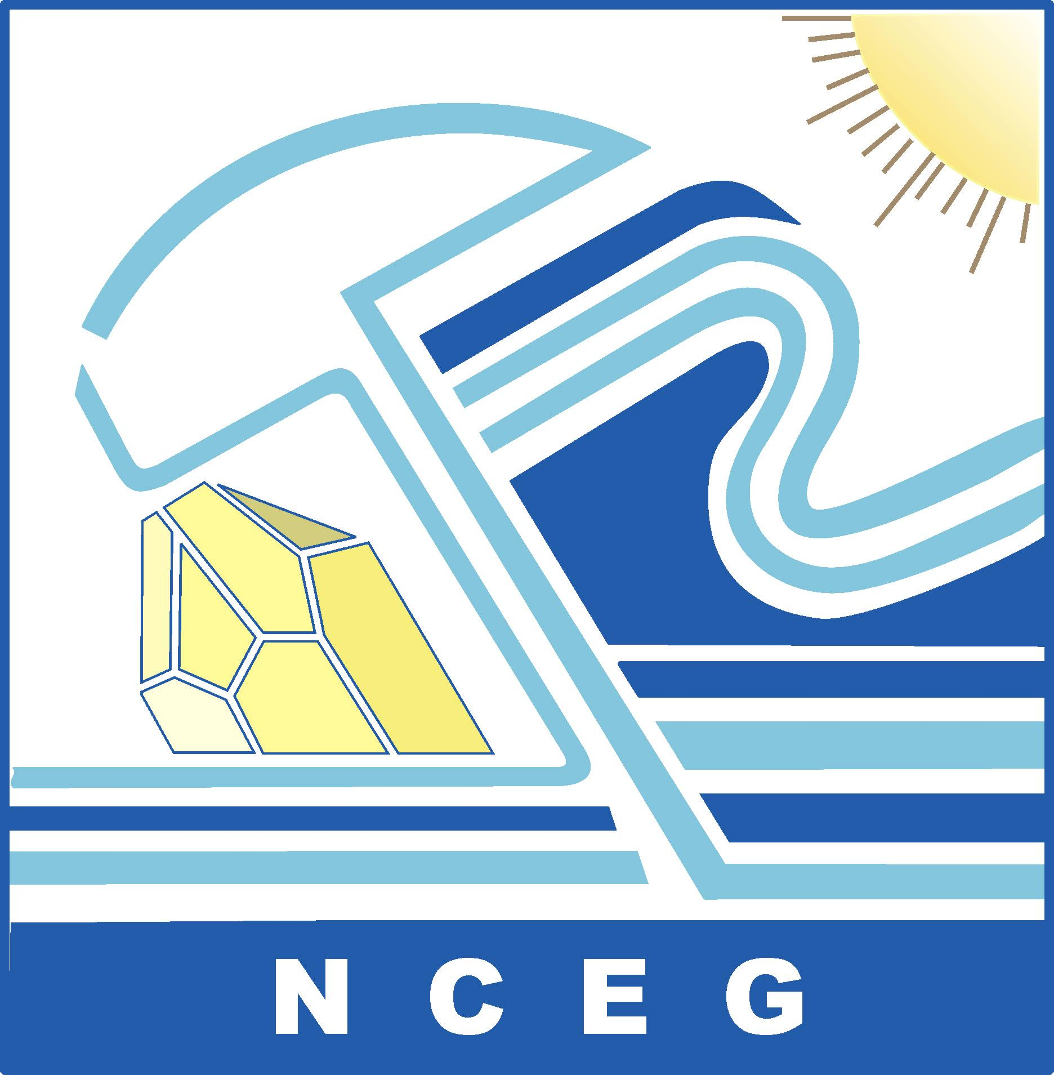 | NATIONAL CENTRE OF EXCELLENCE IN GEOLOGY  UNIVERSITY OF PESHAWAR  Peshawar-25120, Khyber Pakhtunkhwa, Pakistan  Phone: +92-91-9216427; 9216429 Fax: +92-91-9218183  Web: http://nceg.upesh.edu.pk/
 |  | April 27, 2012

APPLICATION FORM
WATER USE EFFICIENCY: CONCEPTS AND PROCEDURES
16-17 May, 2012
National Centre of Excellence in Geology
University of Peshawar
Name (Mr/ Ms/ Engr./Dr)
Designation |  | Gender
Department/Organization
email |  | Phone
Mobile/Cell Number |  | City
Province |  | Education
Current Mailing address
Accommodation Required  Only for Participants from outside Peshawar | Yes | No
Nominated By:

Name and Office Seal

Please Note:

- Attach your detail Curriculum Vita/Resume
- All candidates shall be informed within three days of submission of applications about the program and the confirmation of their participation
- For Queries please contact: wajeedaali@gmail.com

